Game Prototype Task 1

Objectives
After completing this lab you should be able to:
- Use bitmap images to construct simple animated graphics allow the player to control image movement.

To start with we shall simple load a bitmap into a program, and display it on screen.
A bitmap is a type of simple graphic image, which contains a colour value for each pixel of the image. The bitmap we will use in this lab is shown below.

The images you need for this lab can be found in the course-materials folder.
Tank1.bmp, tank2.bmp…tank8.bmp

The Tank1.bmp image should appear similar to the one shown below:
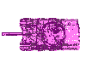

Do the following:
- Create a new folder
- Copy the tank image files into this folder (8 Of them)

Lab: Load and Display an Image in a C# Application
start a new Visual C# project

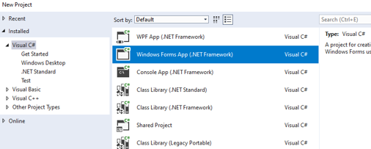

Use a suitable name and save to a suitable folder.

The Form

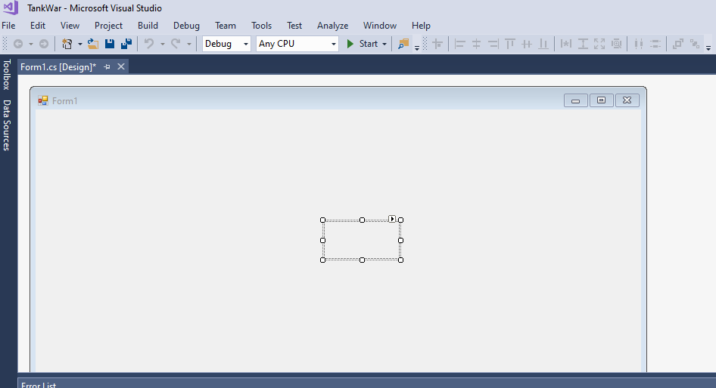
You will see a screen such as shown here. The form is used to create the visual aspects of the project.
Onto this we will place controls such as images. Each control including the form has properties. Properties are the values that can be changed e.g. Height and width, colour, the image file to be shown.

The Properties Window

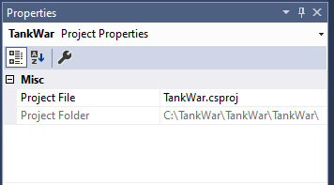
These properties can be gained through the properties window.
To get the properties window select the view menu followed by properties window. You should see the properties window on the right of your screen. The properties window will show the properties of the selected object. In the example here it is the properties of the form that are seen.

The Solutions Explorer

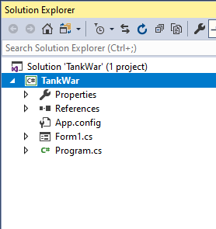
Above the properties window you will see the solution explorer.
This shows the files that are contained in the project, for example Form1.cs.

The Toolbox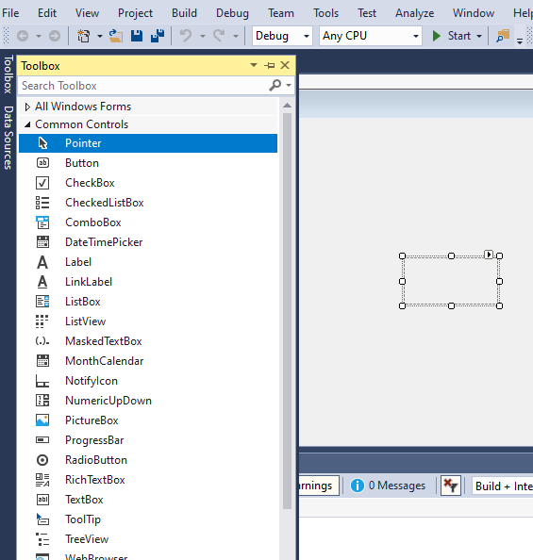

We are now going to put a pictureBox control onto the form. The control will hold the tank image. Select View and subsequently Toolbox. You will see the toolbox click on the controls and use the down arrow until you reach the pictureBox control. Double click the pictureBox control will place one on the screen.

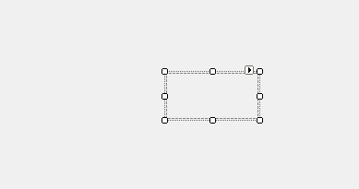

Click and drag the control to the position that you want it.

We will now use the properties to get the image.

Select the pictureBox and the properties window will show the properties for the pictureBox. Select the image property and you will be presented with a dialogue box from which you can select ‘import’ and ‘local resource’ then navigate to and select an image. Navigate to the folder where you saved the tank images and select Tank1.bmp.

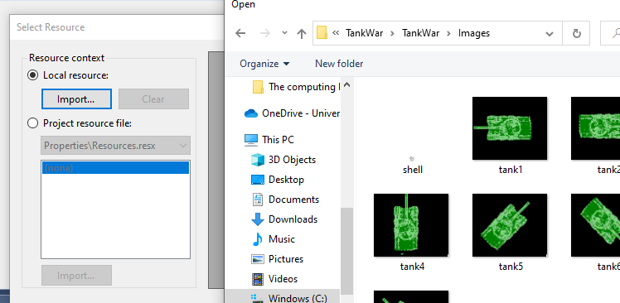

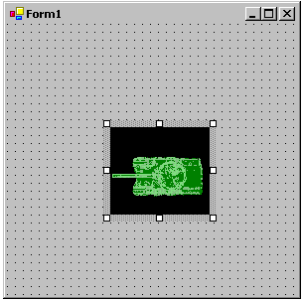
The project should now look similar to that shown here.

For the image also set the following properties: click on the tank image and set the following properties in the properties window:

Then select the form control by clicking on the form:

Note: the properties window will reflect the properties of the selected object so if you want to change the properties of the form select the form by clicking on it.
The properties window will have the properties for the form

Change the following property:

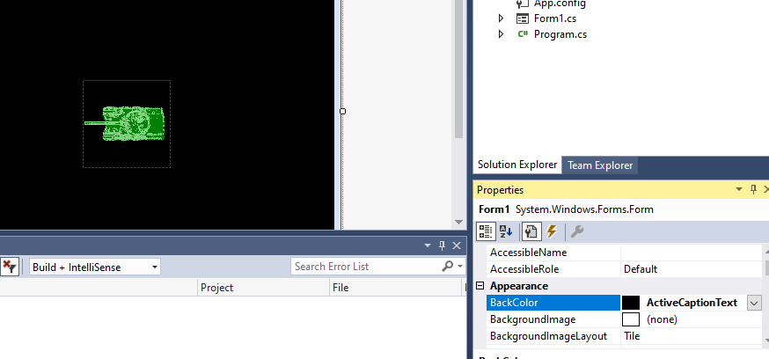

Maximise the window at startup by setting the maximised property of the form control:

Now run your program to test that it works:

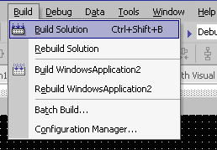

We first of all need to build the project. Every time that you make changes to your project you must build/Rebuild the Solution.

Hopefully you will see the output as below, which means that there are no errors in the project.

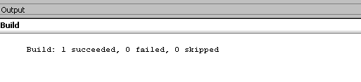

If there are no errors then we can run the project by selecting Debug and Start (without debugging)

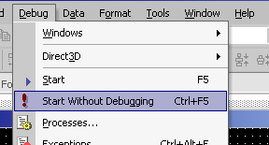

You should then see the following screen.

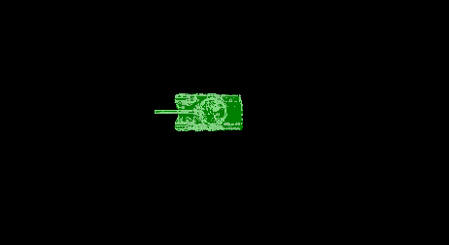

The tank doesn’t do anything as yet and so we must begin to write code.
To get to the code window Select view and Code. You will see that there is already a lot of code there. This is code that is generated automatically when you start an application and also some generated when we put controls onto the form.

Lets look at the generated 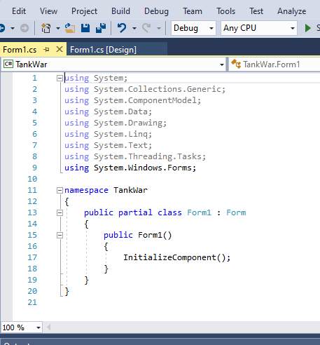
Pre-written classes that are included.

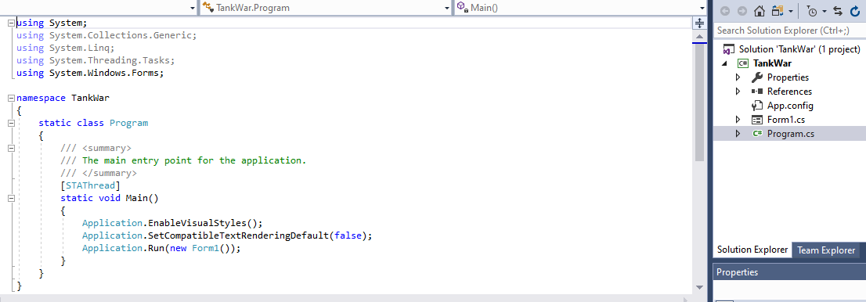
The start point for code execution

The application is run showing form 1.

NOTE: DON’T CHANGE ANY OF THE GENERATED CODE

We must add our own code to this framework to make our applications do what we intend.

Part 2: Animated Graphics with Sprites
We must use multiple images of a tank, facing in all the directions in which movement is possible, and to combine these so that when the player wants to move left e.g. by pressing the left button the image will change to the left facing tank etc.

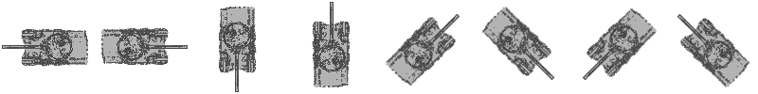

An example of pseudocode for tank direction in four directions:

If the user selects ‘A’ then
Set direction to left
If the user selects ‘D’ then
Set the direction to right
If the user selects ‘W’ then
Set the direction to Up
If the user selects ‘S’ then
Set the direction to Down

Each direction will be signified by a change of image

First of all we need an event to change the image. The event we are going to use is an OnKeyDown event i.e. the code will execute when the key is pressed down.

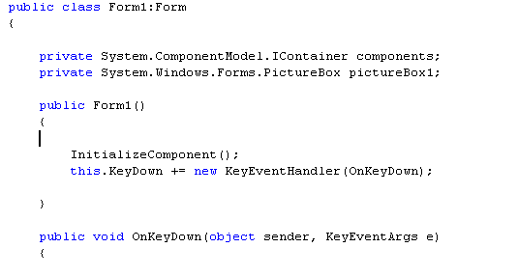

// Code associated with the key goes here
}

Example code:

if(e.KeyCode.ToString()=="A")
{
pictureBox1.Image = Image.FromFile("E:/tank1.bmp");

}

if(e.KeyCode.ToString()=="D")
{
pictureBox1.Image = Image.FromFile("E:/tank2.bmp");

}

This will be inserted within the onKeyDown function - where you see:

// Code associated with the key goes here

Exercise add the code for the up and down directions.

You should now be able to change the direction of the tank 4 ways.

Using arrow keys to move your tank

We want the player to be able to control the movement of the tank via keys on the keyboard i.e. when the user presses a key we will want to execute the code. Therefore we can use the same event as for changing the direction i.e. holding the key down the tank will move in that direction.

Two properties of the picture box are used to move the tank up and down. The Left property will move and the top property is the value of the vertical position, used to move the tank up and down.

- If we add to the left position the image will move right.
- If we subtract from the left position the image will move left.
- If we add to the top position the image will move down the screen.
- If we subtract from the top position the image will move up the screen.

When we move the image to a new position we must refresh the image i.e. re-paint it to the screen.
Lets see how this will work by trying try the following code:

if(e.KeyCode.ToString()=="A")
{
pictureBox1.Image = Image.FromFile("E:/tank1.bmp");

pictureBox1.Left = pictureBox1.Left - 5;
pictureBox1.Refresh();

}

To move up:

if(e.KeyCode.ToString()=="W")
{
pictureBox1.Image = Image.FromFile("E:/tank4.bmp");
pictureBox1.Top = pictureBox1.Top - 5;
pictureBox1.Refresh();
}

This code would be would be placed as demonstrated here:

Add the code to move the tank to the right and down the screen.

Exercises

Add functionality so that the tank will move in eight directions.

Add another tank and use other keys so that you will have two tanks on the screen that each of two players can move independently.

Challenge 2: Modify the final program to prevent the player from being able to drive the tank off the edge of the screen. Alternatively, can you make the tank appear at the opposite side of the screen when the player drives it off one side.

